Unit 2 What time do you go to school?  (The 1st period Section A 1a-1c)  Teaching aims(教学目标）  1.谈论日常作息时间。  2.询问、表达时间。  3.学会用频度副词usually  Language points(语言点）  1.要求掌握以下句式：  （1）-What time is it?（将3b中的语言点前移）  -It's…  （2）-What time do you usually…?  -I/we usually…  2. 要求掌握以下词汇：  （1）名词：time, shower  （2）动词短语：go to school, get up, take a shower,  （3）副词：usually o'clock  （4）疑问代词：what time  Key points（重点）:  一般现在时的特殊疑问句，即掌握:  “What time do you usually…？I/We usually…”这个句型  Teaching difficulties（难点）:  助动词do在一般现在时的特殊疑问句中的用法。  Teaching steps (教学步骤):  1.Warming-up and revision（课堂热身和复习）  (1)欣赏世界名曲《钟表店》，学生交流收集到的时间谚语。  （2）Game：  T：（指着自己）one  然后指着直排的一个学生  S1:two (T helps S1,并提示起立）  S2：（教师再指着第二个学生） three  S3:four (T helps S3, 并提示起立)  S4：five  S5：six （一般情况下，此学生就会自动报出，如果没反应，提示其它学生提供帮助）  …  S60：60  2、Presentation（呈现新知识）  T：（拿出一个自制的钟表，此钟指针会转动）  I have a nice clock. Do you want to have a look?  Ss: Yes.  教师指着此钟：What time is it now?  Ss：It's……（T help Ss）  T：（教师转动指针）What time is it now?  Ss: It's…（教师启发）  （教师板书：What time is it ? It's …）  T: Follow me :“What time is it? It's…”  Read it in groups.  T：（教师转动指针并引导组之间对话）  Ss: What time is it?  Ss: It's…  （操练三四次）  3、Drill（操练）  T：Ok. The whole class, please write down time on the paper.  Are you ready ?  Ss: Yes  T: Well. Practise it in pairs. What time is it?  It’s…  T：act （三四组）  4、Consolidation（巩固）  Play a game and practise more on the pattern“What time is it? It’s…”  T：（每大组选一个代表，分别用What time is it ?向教师发问，教师便用以下句子启发）：  You can ① have breakfast 复习以前的短语  ② have lunch 复习以前的短语  ③ have supper 复习以前的短语  ④ go to bed … 复习以前的短语  ⑤ get up （做动作） 为下面单词呈现作铺垫  ⑥ go to school（做动作 ） 为下面单词呈现作铺垫  ⑦ take a shower（做动作） 为下面单词呈现作铺垫  S1：It's…  S2：It’s…  S3: It’s…  S4: It’s…  5、Presentation（呈现新知识）  T：（总结上述游戏）Now let's look at the clock .（将时钟调整到六点钟）  What time is it?  Ss: It's six o'clock  T: o'clock（板书）. Read after me.  Ss: o’clock.  T：We will……（做“起床”的动作，并提供一男孩起床的照片）  Ss: get up（T helps Ss）  T：Follow me ：get up（板书）  T：（指着此图片中的男孩）What's he doing?  Ss: He's getting up.  T: And what am I doing?  Ss: You're getting up.  T: Right. What time is it now?（一边说一边将时钟调到七点）  Ss: It's 7 o'clock.  T: We will……（做“上学”动作，并提供一群孩子上学的图片）  Ss: go to school（板书）T：go to school. Together.  T: （指着图片）What are they doing?  Ss: They are going to school.  T：（指着自己，背上书包，做出“上学”的模样）  What am I doing?  Ss: You're going to school  T: Good .And what time is it?（将时间调整到晚上十点）  Ss: It's 10 o'clock.  T: We will……（做“洗澡”动作，并提供一男孩洗淋浴的图片）  Ss: take a shower（板书）  T: Together  T:（指着图片）What's he doing?  Ss: He is taking a shower.  T:（做出“洗澡”的动作）What am I doing?  Ss: You're taking a shower.  6、Work on 1a （完成P651a）  播放磁带。如学生有畏难情绪，可播放磁带两遍，磁带播放以后，给1分钟时间，继续完成1a，然后校对答案.  在完成1b中，一般情况下，可能要播放磁带两遍。如有必要，也可以同桌或两人小组为单位，讨论答案。  T: Ok. Please open your book.  Look at 1a, listen and match the words and the pictures.  7、Work on 1b （完成P651b）  T: Now let's listen to the tape, match the times and actions.  T: Well, let's check the answers.  8、Consolidation.  T:（当答案校对到九点钟时）But I often take a shower at ten o'clock.（一边说一边高举自己洗澡的图片，此图片上课前画好）I usually（突出usually）take a shower at ten o'clock  T：Read after me: usually  T：Please hold your pictures and tell me “I usually…”  （这些图片包括洗淋浴，起床、上学、跑步、吃饭等日常活动，并事先叫学生在课前画好）  S1：I usually take a shower at nine o'clock  S2：I usually go to school at six o'clock  S3：I usually…  S4：…  9、Work on 1c（完成P651c）  （1）T：（针对最后一个发言的学生说的句子，问其它同学 What time do you usually…？）  S1：I usually…at…（T help S1）  T:（再问另一学生）What time do you usually…？  S1:I usually…at…  T：Read after me  What time do you usually …？（板书）  I usually…at…（板书）  （2）T：Read it in pairs.  学生应听一句跟读一句。老师特别强调语音语调的模仿，建议老师把听力内容打印好发给学生。让他们在听音模仿时可以标上语调，可以先全班  跟读，再让学生个体跟读，老师可以根据实际情况来决定跟读的时间  T: What time do you usually take a shower?  S1: I usually take a shower at …  10、Drill  （1）Make a similar dialogue with the person you like.  （2）Act.  11、Listen and repeat（听音跟读）  T：Now let's listen to the tape and repeat. Please try to read like the tape.  附听原文：  Interviewer: What time do you usually get up, Rick?  Rick: Um, I usually get up at five o’clock.  Interviewer: Five o’clock. Wow! And what time do you run?  Rick: Um. At six o’clock.  Interviewer: Hmm. And breakfast?  Rick: Seven o’clock.  Interviewer: What time do you usually shower?  ]Rick: Uh, eight o’clock.  Interviewer: What time do you usually go to school?  Rick: I usually go to school at nine o’clock.  12、Follow up （进一步扩展）  老师根据学生的实际水平，可以让学生自由发挥编对话，也可以以板书对话框架。例：  A：What time do you usually…,…？  B：Um, I usually…  A：…. And what time do you…？  B：…  （1）T：Now it's your turn to make up your own dialogues. Please work with your partner.  （2）T：（事先将workbook中P43的第4题的图片扫描到PPT中并配上录音，其录音分别是：  ①I do sport at 6:30  ②I take a shower at 7:00  ③I have breakfast at 7:15  ④I go to school at 8:00）  You can ask Justin some questions.  First, I will try. What time do you usually take a shower?（然后点击声音②）Come on!  S1：What time do you usually do sport?  S2:…  S3:…  T: Please open your workbook. Look and write sentences.  （有了前面的铺垫，这一部分对于学生就更加容易）  T: Ok, please tell a story about Justin.  S1:……  S2:……  13、Homework:  Oral work:  （1）Read and recite the listening tapescript.  （2）Go on making up your dialogues with the partner and polish it（继续和小组成员编对话，并完善对话）  Written work  （1）Copy the phrases in 1a twice （抄写1a的词组两遍）  （2）Finish Ex.1 of the workbook.  （3）调查朋友的作息时间，操作过程如下：  - 教师设计如下表格，分发给各小组。  ②学生自由组合成3~5人小组，围坐在一起，相互提问，并把答案记录在表格中。  - 各小组成员根据表格内容，以“……的一天”为题，依次叙述作息时间，并写成一篇短文。  Unit 2 What time do you go to school?  （The 2nd period Section A 2a-2c）  Teaching aims （教学目标）  1、谈论日常作息时间  2、询问、表达时间  Language points（语言点）  要求掌握以下句式：  ——What time does sb. verb?  ——Sb. verbs at …  Key points（重点）：  一般现在时的特殊疑问句，即掌握：  What time does he/she…？  Teaching Difficulties（难点）：  学生对于一般现在时，特别是单数第三人称的谓语动词的变化没有一定的概念，常常出错。  Teaching steps（教学步骤）  1、Warming - up and revision（课堂热身和复习）  读的时候注意节奏，可以让学生拍手打节拍，速度由慢到快，从而掌握昨天学过的重点句型。  （1）Student chant:  What time do you usually get up?  I usually get up at 6:30.  What time do you usually go to school?  I usually go to school at 7:10.  What time do you usually go home?  I usually go home at 5:00.  What time do you usually go to bed?  I usually go to bed at 9:00.  （2）Play a game:  ①老师为学生提供分别装有动词、时间和地点短语小纸条的盒子。  ②学生上台任意抽取纸条，要求用“I”开头组成句子并大声地在全班同学面前讲出来。  ③抽学生以第三人称单数形式复述。  （3）Find mistakes.  叫一个学生读前一天写的短文，其他同学认真听，并记录短文中出现的错误，读完以后，让学生指出错误。  2、Work on 2a.（完成2a）  T：But my friend Rick does the same thing with his family. Do you know?  Ss: No.  T: Let's listen  S1:（启发学生回答）  T：Listen again and fill in the blanks.  3、Work on 2b.(完成2b)  建议：如有需要，老师可播放磁带两遍，并给出一分钟时间校对答案。  T: What time do they take a shower? Listen again and complete the shower schedule.  T：(校对答案)  4、Work on 2c.(完成2c)  T：××，When does Alicia take a shower?  S1: She takes a shower at 8:00  T : （Read after me）  When does Alicia take a shower?  She takes a shower at 8:00.  Read it in groups.  T：××，when does Jerry take a shower?  目的：通过此机械操练及时巩固所学新句型。  S1:…  T: Look at 2b and make a dialogue like this.  5、Listen and repeat （听音跟读）  学生应听一句跟读一句。老师特别强调语音语调的模仿。可以先让全班跟读，再让个体跟读，老师可以根据实际情况来决定跟读时间  T: Now let's listen to the tape and repeat . Please try to read like the tape.  附：听力原文  Interviewer: You have a big family, don’t you, Rick?  Rick: Yes. I have two brothers and two sisters.  Interviewer: Wow! How many showers do you have?  We only have one shower.  Interviewer: Is that difficult?  Rick: No, because we have a shower schedule.  My brother Bob takes a shower first,at 5:00.  Interviewer: Wow! That’s early!  Rick: Yeah. Then my sister Mary takes a shower at 6:00. Next my brother Jerry takes a shower at 7:00,then my sister Alicia at 8:00.  6、Follow up（进一步扩展）  在黑板上或幻灯片上呈现录音原文  （1）T：Now it's your turn to make up your own dialogues like this. Please work with your partner.  （2）T：And now say something about Rick. Four people make a group and try. You may begin it like this, “My friend Rick has a big family. He has two brothers and four sisters. But they only have one shower…”  （3）T：Here is a picture about Lu Lilu What do you think about his schedule? First tell us his schedule in English. Then give a healthy one for him. Do this part in pairs first. And then choose some best groups to speak in the front.  （你认为Lu lilu周末生活好吗？请你看图与同伴一起为Lu lilu设计一个更有益健康的周末安排）  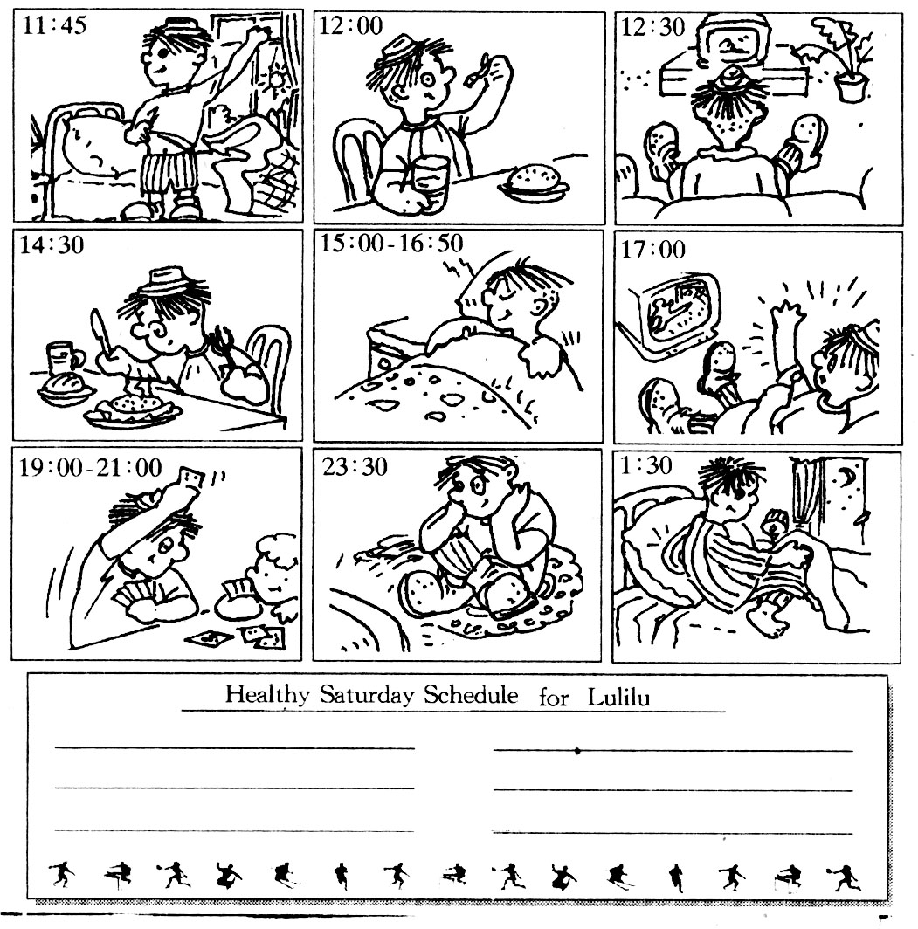  7、Grammar focus.  （老师用中文总结这两天所学的语法点）  （1）T：这两天，我们学习了以What time引导的一般现在时的特殊疑问句形式。  它的结构式是：What time do sb. Verb（原形）?  （非第三人称单数原形）  Sb. Verb at …（板书）  What time does sb. Verb（原形）?  （第三人称单数）  Sb.verb s at…  在这一句型中，要特别注意助动词用do还是does。  注：①以上结构板书，并配以解释。  ②verb后有时也要加es。当此verb以s,x,ch,sh,o结尾时加es. watches ，does.  Fill in the blanks with the words in their proper forms.  ①——What time （do）they .  （get up）？  ——They （get up）at five o’clock.  ②——What time （do）Tom .  （take a shower）?  ——He （take a shower）at 19:15  ③——What time （do）he go to school?  ——He （go）to school at 5 o’clock.  8、Homework  Oral work:  （1）Read and Recite the listening tapescript.  （2）Go on making up your dialogues with group members and polish it （继续和小组成员编对话，并完善对话）  Written work  1.Finish Ex.2and Ex.3 of the workbook  2.Design a better schedule for your family at the weekends and write it down in your exercise book.  Unit 2 What time do you go to school?  （The 3rd period SectionA3a~Part4）  Teaching aims （教学目标）  1、用When询问时间  2、表示频率的副词  Language points （语言点）  1、要求掌握以下句式：  ——When do you usually …?  ——I/we … prep…  2、要求掌握以下词汇  （1）名词：work，hour，hotel，bus，night，morning，job，home.  （2）动词及动词短语：listen，go to work，get to，go to bed  （3）其它：after，am  Key points（重点）：  1、一般现在时的特殊疑问句，即掌握：When do you usually …?  2、频度副词 usually 的熟练运用  Teaching difficulties（难点）  助动词do，在一般现在时的特殊疑问句中的用法：  Teaching steps（教学步骤）：  1、Warming - up and revision （课堂热身和复习）  （1）Watch a video clip about Mickey Mouse's Day.（观看一段米老鼠一天活动的录像剪辑）  （2）Revision  T：What time does the mouse get up / have breakfast/…？  S1：…  2、Presentation（呈现新知识）  T：（在问问题中适时引出一些新词汇）  What time does Mickey Mouse usually get up?  What time does Mickey Mouse usually get up? We can also say,  “When does Mickey Mouse usually get up?”  Follow me: When does Mickey Mouse usually get up ? （板书）  S1:He usually gets up at six.  T: at six am or pm?  Ss: am（板书）  T：6 am is in the…？  Ss: In the morning （T helps Ss）（板书）（引出morning同时为SectionB 作准备）  T：Read after me ：in the morning.  T：In the morning I usually do sport. What about you?  S1: In the morning I usually…  S2: In the morning I usually…  S3:…  T: But 6 pm is in the …?  Ss: evening （T helps Ss）（板书）  T：Right. Follow me: evening ,in the evening（为section B 作准备）  T：And when does Mickey Mouse leave school?  S1:He usually leaves school at 5 o'clock  T: Then what does he usually do?  S1:He usually goes home.（T helps S1）  T: Read after me: go home.  T: What time do you usually go home?  S1: I usually go home at…  S2：I usually go home at…  S3：I usually go home at…  T：Look at the video, too.  What does he(米老鼠) do?  S1:He is a student  T: Yeah. He goes to school in the morning and goes home in the afternoon Right?  Ss: Yes.  T: How many hours is he at school in a day?  From eight to nine is an hour. Do you know?  Ss: Yes  T: Read after me: hour（板书）  T: How many hours is he at school in a day?  About……  S1: 8 hours  T: What about you?  S1:……  T: Then he goes home. After school, he goes home. Right?  Ss: Yes  T: Read after me :after（板书）  T: After he comes into home, after he gets to his home.  T: Follow me :get to  T: After he gets to his home, what does he do?  He does homework to in the ……  Ss: in the evening.  T: In the evening. we often say at night.  T: Follow me :night  T: At night, I usually watch Tv. What about you?  S1: At night, I usually…  S2:At night, I usually…  S3:At night I usually……  T: Suppose we get to Beijing at night, where can we stay?  Ss:……（学生能讲出hotel最好，如不能，帮助学生讲出hotel）  T：After you get to the hotel, no people is there.  No people is working there.  T: work （板书）  T：But a boy is working at night. What is his work? Do you know?  Ss: No  3、Work on 3a(完成3a).  建议：给出一分钟左右时间校正答案。  （1）Read through the passage and tell me  （2）Read it again and match the pictures.  (3)Answer questions:  What does he do after he get up?  Does he go to work after breakfast? What does he do?  How does he go to work? By bus or on foot?  What does he do before he goes to bed?  What does“What a funny time to eat breakfast!”mean?  Follow up的建议：  ①刚开始时，尽量引导学生利用“What time do you usually…？” 句型  ②等两个同学问问题后，教师及时总结：“What time do you usually…? ” We can also say,“When do you usually…？”  ③接下去，鼓励学生用“When do you usually……？”句型提问。  4、Follow up （进一步扩展）  T：My friend Da Bao likes Scott's work, so he gets to Sai Te Hotel . But he doesn't find him.  T: There are many children in the hotel. Look, they are coming.（事先叫五个学生准备扮演Scott）Please ask them questions to find the real Scott.  5、Work on part4.（完成P67第四部分）  T：Now six people make a group, and ask the other students when they usually go to bed . The leader lines up from the earliest to the latest bedtime.  T:（活动以后）Let's listen Group1…Group2…  6、Work on part 3 of self –check  T: Now I want to know something about what you do on weekends. You can go, ask your classmates and fill in the forms. Then you have a report.  T: You may begin it like this "Ma Li gets up at …"  7、Work on Ex.5 of the workbook（完成workbook 44页第5题）  T: Please open your workbook and finish Part 5  8、Homework  Oral work:  （1）Read 3a and recite it.（读背课文3a）  （2）Go on making a survey to find out what your classmates do on weekends.（继续作一个有关你同班学生所做的调查）  Written work:  （1）Copy the new words and phrases in 3a twice（抄写3a的新词和词组两遍）  （2）Write down the survey about what your classmates do on weekends in your exercise book. You can do it like the reporters in class.  Unit 2 What time do you go to school?  (The 4th period Section B 1a~2c)  Teaching aims（教学目标）  1. 用When询问时间  2. 表示频率的副词  Language Points（语法点）  1. 要求掌握以下句式：  —When does sb(第三人称单数) usually verb?  —Sb(第三人称单数) verbs prep….  2. 要求掌握以下词汇  （1）名词：afternoon evening homework  （２）动词短语:do homework, go home.  Key Points （重点）：  １.一般现在时的特殊疑问句即掌握Ｗhen does sb(第三人称单数). usually verb?  2.频度副词usually 的熟练运用  Teaching difficulties（难点）：  助动词does 在一般现在时的特殊疑问句中的用法：  快速反应：通过这个游戏使学生进入上课状态，与此同时复习前几课学过的单词。  Teaching Steps （教学步骤）  1、Warming - up and revision （课堂热身和复习）  A game: quick responses.  T：Let’s play a game. Please give me a word of each sentence and spell it. The first one who finishes the sentence will get a star.(Divide the students into several groups and draw stars on the blackboard to encourage the students.)  (1).Tom goes to ______ on weekdays, and he works very long hours.  (2)._____ lunch, lucy goes home.  (3).To_____ to the hotel, Jack takes the number 4 bus.  (4).Many people love to ______ to music.  (5).Sally usually______ a shower after school.  (6).Tom’s father often works all _____,because(因为)he works in a night club(夜总会).  Keys:  (1)work (2)After (3) get (4) listen (5) takes (6) night  注：由于带1a中的新词 afternoon. evening 在前一个Period 中已引出，这里就不再引了.  给出一份钟时间给学生配对  2. Work on 1a（完成1a）  T:（Point to the stars on the blackboard and make brief comments on the results of the game） people usually do things, too （指着Section 1B 1a）Let's look and match  3. Work on 1b(完成1b)  T: Please check the answers with another student  T:（集体对答案）  T: （对答案以后，指着那个小男孩）  What's the boy doing?  Ss: He is doing his homework（T helps Ss）  T: Follow me： do homework（板书）  Ss:…  T：Do you usually do homework?  Ss: Yes  T: But when do you usually do your homework?  Please tell me ?（举手示意）  I usually…  S1: …  S2: …  S3: …  T:Oh, I see. But I don't know when my friend Rick does homework  T: Could you help me listen and tell me ?  Ss: Yes.  T:（学生听完）Who can?  S1:…  4. Work on 2a(完成2a)  T: Well, Listen again and circle the activities you hear.  建议：如果学生有畏难情绪，可播放两遍。  5. Work on 2b(完成2b)  T: Then look at 2b,listen and write.  6. Listen and repeat（听音跟读）  T: Now let's listen to the tape and repeat. Please try to read like the tape  要求同上一个period的要求。  附：听力原文  Interviewer: Thanks for the interview, Rick.  We want to know about your day.  Rick: OK.  Interviewer: When do you get up?  Rick: When do I get up? Hmm. Usually around five o’clock. Then I run around six.  Interviewer: You run at six in the morning?  Rick: Uh-huh.  Interviewer: And what time do you eat breakfast?  Rick: Breakfast? Usually around seven. And then I usually go to school around eight o’clock.  Interviewer: Wow! And you go home at…?  Rick: Four-fifteen in the afternoon.  Interviewer: And what do you do in the evening?  Rick: I do my homework around five- thirty. And I eat dinner at seven-fifteen. And I go to bed at nine o’clock.  Interviewer: That’s early! But then you get up early.  Rick: Uh-huh.  7.Work on 2C（完成P68 2c）  (1)T:(把听力原文提供在幻灯片成黑板上)  Let's look at the dialogue.  When does Rick usually get up?  Ss: He usually gets up at …(T helps Ss)  T: Follow me: When does Rick usually get up? He usually gets up at …（板书）  T: Read it in groups  (2) T: Look at the dialogue carefully and memorize it for two minutes. Then we’ll have a competition.  T: Ready?  Ss: Yes.  T: Well. In our class, there are two halves. Right?  Ss: Yes.  T:OK! This half, ask questions like“What time does Rick usually…?”That half, please.  …  T:(一分钟以后)Exchange.  T: Who wins the game?  (3)T: Imagine what Beckham usually does in a day. I’ll give you a time(5:30/6:00/7:30/…)Please say a sentence like,“Beckham gets up at 5:30.”  此活动类似于故事接龙。  8.Homework:  Oral work:  (1)Listen to 2a,read and recite it(听读背诵2a中的对话)  (2)Go on making up your dialogue with your partner and polish it  （继续和同伴编对话，并完善对话）  Written work:  - Finish Ex.6 of the workbook.  - Make a routine for your dream(梦想)day.  Unit 2 What time do you go to school ?  (The 5th period Section A 3a~self-check)  Teaching aims：（教学目标）  1、通过阅读找出重要文中信息。  2、通过小测试来复习本单元所学过的重点内容。  Language points：(语言点）  A、要求掌握下列词汇  letter, around, start, write, tell, me, best, wish, soon, Saturday, survey, late  B、Review the key words presented in this unit.  Key points and teaching difficulties：（重难点）  巩固以When ,What time引导的特殊疑问句形式。  Teaching steps(教学步骤)  1、Warming-up and revision(课堂热身和复习)  A game  通过游戏使学生进入上课状态，与时同时复习前几个period中的重点。  T：Let's play a game. Six people make a group. Every group will get a piece of paper. There are some pictures on it. Listen and fill in the time. Then put them in the right order. Let's see which group can finish most quickly and best?  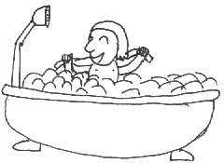  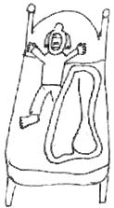  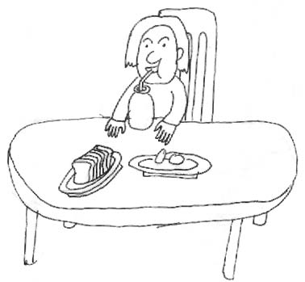  1._______  2._______  3._______  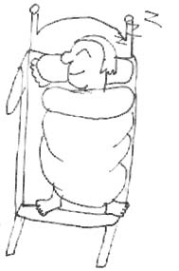  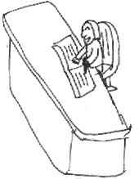  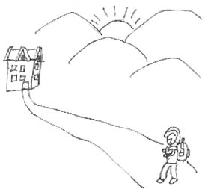  5.________  4._______  6.________  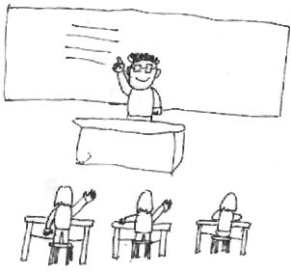  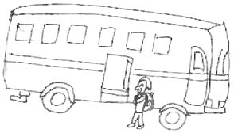  7.________  8.________  The right order:_____________________________________  附：I have a good friend. His name is Wang Tao. He usually gets up at 6:00.Then he often takes a shower at 6:20. He has breakfast at 6:30.  After that, he usually takes a bus to school at 7:00. He has classes at7:30. After school, he does his homework at 4:30and goes home at 5:00. At 9:00, he goes to bed.  (Keys:1. 6:20 2. 6:00 3. 6:30 4. 9:00 5. 4:30 6. 5:00 7. 7:00 8. 7:30  The right order:2、1、3、7、8、5、6、4)  2.Work on Part4(完成P69第四部分)  Pairwork：Imagine you are a famous movie star . Fill in the timetable with the things you usually do. Then share the information with your partner.  T: Well done ! Well, Let's see who wins the game.  T: Now, imagine you are a movie star. Please fill in the time table with the things you usually do.  T: Please look for your friend in our class. You can ask questions like“What time do you usually…?”  T: Now please make a report. You can do it like this: …is a movie star. He/She usually…  3、Presentation.(呈现新知识)  T: Thank you .And I want to know more about you. You can write(手势) a letter(拿出信纸) to me about it. It is for your homework OK?  在处理3a中注意：给学生一分钟时间完成此项任务，留有一分钟校对答案并处理几个剩下的生词，板书并引导学生上下文猜这样几个单词的意思。  T: Read after me: write(板书)letter (板书)  4、Work on 3a(完成3a)  T: Here is a letter from Jane to Mona. Would you like to read it ?  Ss: Yes.  T: Please read it quickly and write down what she does at these times  5、Work on 3b(完成3b)  T: Now Mona wants to answer the letter. But he isn't good at English .Could you help me?  在处理3b中注意：教生词soon,best,wishes,以及书信的格式。  Ss: Yes /No .  T: Don't worry. Here's a letter. It can help you .  T：I'm sure you can help Mona write a letter to Jane now. Right?  Ss: Yes.  6.Work on Part1、2  Make a list.  将全班分成两大组。叫他们分别罗列出日常起居生活中的动词。看哪个组列得多，为获胜。此步的目的是扩大词汇量，刚好与Self-check的第一、二部分吻合。  7.Enjoy just for fun on P70.(欣赏Just for fun)  (1).学生分角色朗读对话。  （2）有可能的话，学生看录像，并模仿进行表演。  8．Grammar test.  一、根据首字母填空。  1.He u draws at six o in the morning.  2.Tom w for long h , so(因此)he often goes home late.  Grammar test.(打在幻灯片上，或事先印在纸上发给学生，时间为10分钟)  3.The bus t him to a hotel.  4.The English class will s .please get ready for(准备)it.  5.Xiao Wang wants to w a letter to his pen friend and  t him about his j in China.  二．选词填空。  go to school, get up, take a shower , go to work , get to, listen to , go to bed, do homework, go home  Dear li Lei,  Do you want to know about my day? Well ,I usually _______ at 5:30.Then I ______ at 6:00.I usually ________ by bus ,but my son often ________by bike. After work, I take a bus to _______.I usually ________at 5:30pm.But my son gets back(回来)very late. I often help him __________ after supper. Then I watch Tv. I ________at 10 o’clock.  Best wishes,  Xiao Hai  9.Homework:  (1)Write a letter about your movie star life to me.  (2)Finish Ex.7 of the workbook. | 此游戏类似于体育课的“报数”，但要求遇到2的倍数时，起立。  目的：通过此活动，培养学生的反应能力与复习巩固数字。  注：在这活动中看哪个组的代表猜出的时间与教师设定的时间（将原设定的时间写在纸条上，并在叫学生猜之前给在座的其他学生看）最相近，此话动类似于“幸运52”游戏。
  Name
  Get up
  Have breakfast
  Leave home
  …

